DungLC

Tóm tắt Code

1. BACK_END spring+ jwt

* User {

Set<Role> role;

}

* Role{

Set(Function) function;

}

* Function{}

Cấu trúc project:

* 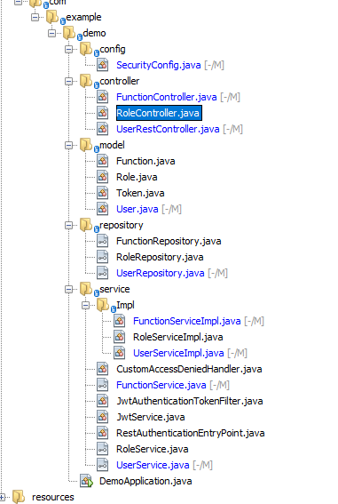

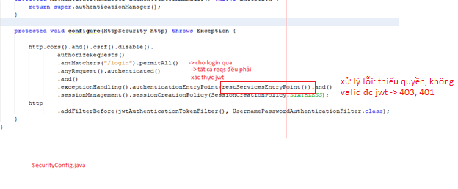

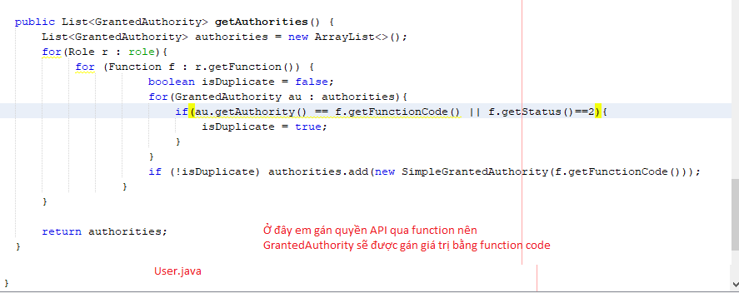

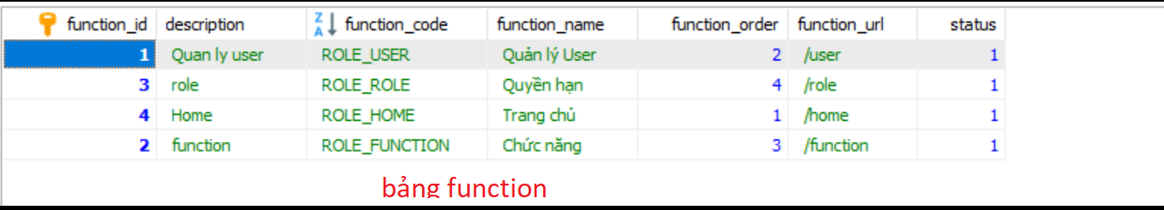

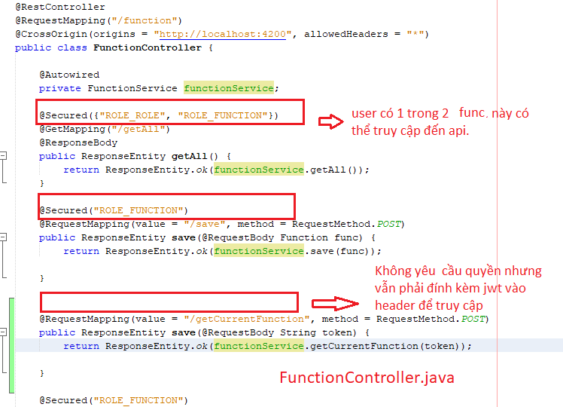

1. FRONT_END Angular

Cấu trúc

